**EPANET’s Workspace**

This chapter discusses the essential features of EPANET’s workspace. It describes the main menu bar, the tool and status bars, and the three windows used most often – the Network Map, the Browser, and the Property Editor. It also shows how to set program preferences.

## **Overview:**

The basic EPANET workspace is pictured below. It consists of the following user interface elements: a Menu Bar, two Toolbars, a Status Bar, the Network Map window, a Browser window, and a Property Editor window

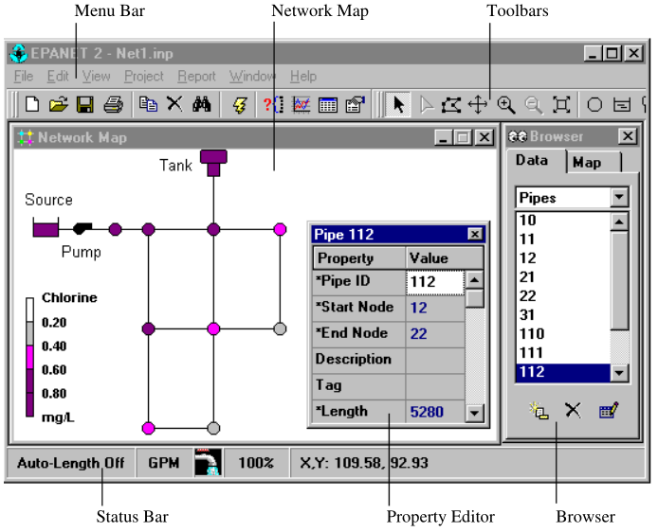

## **Menu Bar:**

The Menu Bar located across the top of the EPANET workspace contains a collection of menus used to control the program. These include:

* File Menu
* Edit Menu
* View Menu
* Project Menu
* Report Menu
* Window Menu
* Help Menu

**File Menu:**

The File Menu contains commands for opening and saving data files and for printing.

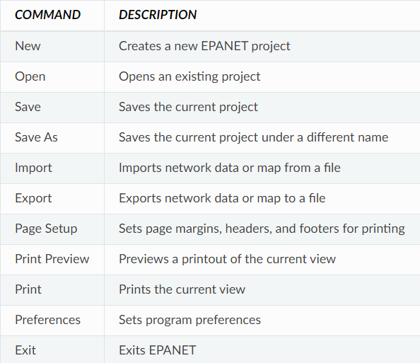

**Edit Menu:**

The Edit Menu contains commands for editing and copying.

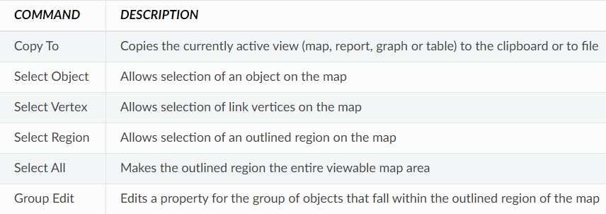

**View Menu:**

The View Menu controls how the network map is viewed.

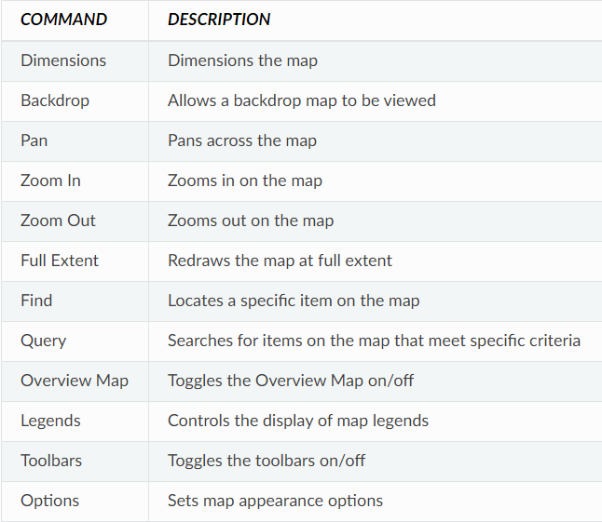

**Project Menu:**

The Project Menu includes commands related to the current project being analysed.

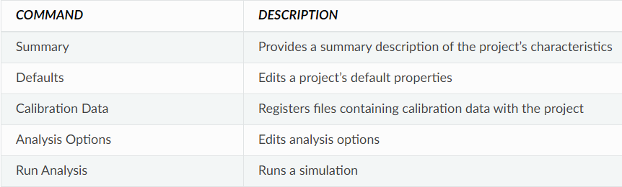

**Report Menu:**

The Report menu has commands used to report analysis results in different formats.

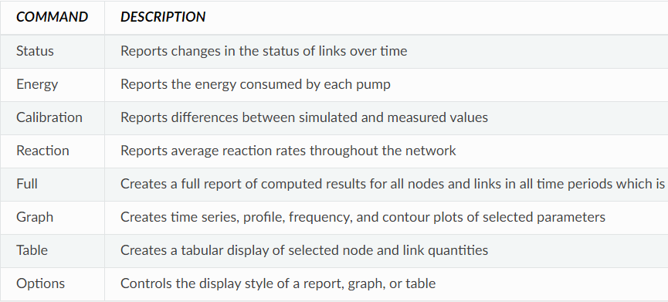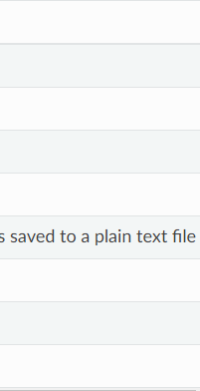

**Window Menu:**

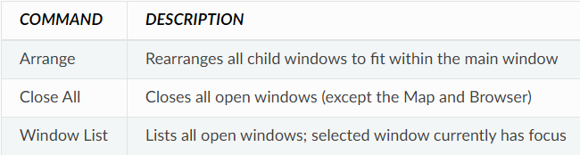

**Help Menu:**

The Help Menu contains commands for getting help in using EPANET. Context-sensitive Help is also available by pressing the F1 key.

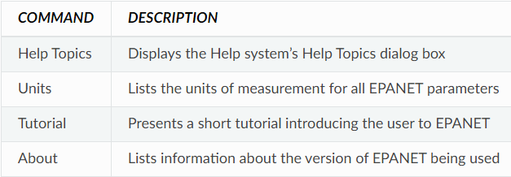

## **Toolbars:**



Toolbars provide shortcuts to commonly used operations. There are two such toolbars:

* Standard Toolbar
* Map Toolbar

**Standard Toolbar:**

The Standard Toolbar contains speed buttons for commonly used commands.

* image40 Opens a new project (**File >> New**)
* image41 Opens an existing project (**File >> Open**)
* image42 Saves the current project (**File >> Save**)
* image43 Prints the currently active window (**File >> Print**)
* image45 Copies selection to the clipboard or to a file (**Edit >> Copy To**)
* image46 Deletes the currently selected item
* image44 Finds a specific item on the map (**View >> Find**)
* image48 Runs a simulation (**Project >> Run Analysis**)
* image47 Runs a visual query on the map (**View >> Query**)
* image49 Creates a new graph view of results (**Report >> Graph**)
* image50 Creates a new table view of results (**Report >> Table**)
* image51 Modifies options for the currently active view (**View >> Options**)

**Map Toolbar:**

The Map Toolbar contains buttons for working with the Network Map.

* image52 Selects an object on the map (**Edit >> Select Object**)
* image53 Selects link vertex points (**Edit >> Select Vertex**)
* image54 Selects a region on the map (**Edit >> Select Region**)
* image55 Pans across the map (**View >> Pan**)
* image56 Zooms in on the map (**View >> Zoom In**)
* image57 Zooms out on the map (**View >> Zoom Out**)
* image58 Draws map at full extent (**View >> Full Extent**)
* image59 Adds a junction to the map
* image60 Adds a reservoir to the map
* image61 Adds a tank to the map
* image62 Adds a pipe to the map
* image63 Adds a pump to the map
* image64 Adds a valve to the map
* image65 Adds a label to the map

## **Status Bar:**



The Status Bar appears at the bottom of the EPANET workspace and is divided into four sections which display the following information:

* **Auto-Length** – indicates whether automatic computation of pipe lengths is turned on or off
* **Flow Units** - displays the current flow units that are in effect
* **Zoom Level** - displays the current zoom in level for the map (100% is full scale)
* **Run Status** - a faucet icon shows:
  + No running water if no analysis results are available,
  + Running water when valid analysis results are available,
  + A broken faucet when analysis results are available but may be invalid because the network data have been modified.
* **XY Location** - displays the map coordinates of the current position of the mouse pointer.

## **Network Map:**

## 

The Network Map provides a planar schematic diagram of the objects comprising a water distribution network. Selected properties of these objects, such as water quality at nodes or flow velocity in links, can be displayed by using different colours. New objects can be directly added to the map and existing objects can be clicked on for editing, deleting, and repositioning. A backdrop drawing (such as a street or topographic map) can be placed behind the network map for reference. Nodes and links can be drawn at different sizes, flow direction arrows added, and object symbols, ID labels and numerical property values displayed. The map can be printed, copied onto the Windows clipboard, or exported as a DXF file or Windows metafile.

## 

## **Data Browser:**

The Data Browser is accessed from the Data tab on the Browser window. It gives access to the various objects, by category (Junctions, Pipes, etc.) that are contained in the network being analysed. The buttons at the bottom are used to add, delete, and edit these objects.

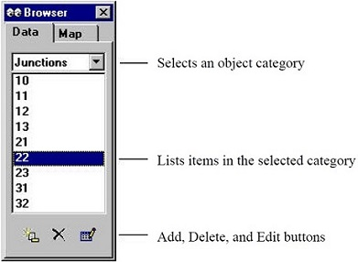

## **Map Browser:**

The Map Browser is accessed from the Map tab of the Browser Window. It selects the parameters and time period that are viewed in color-coded fashion on the Network Map. It also contains controls for animating the map through time.

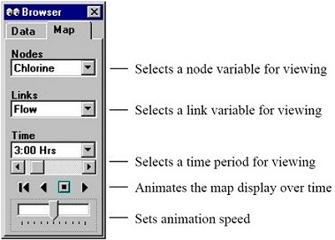

The animation control pushbuttons on the Map Browser work as follows:

image68 Rewind (return to initial time)

image68_2 Animate back through time

image68_3 Stop the animation

image68_4 Animate forward in time

## **Property Editor:**

The Property Editor is used to edit the properties of network nodes, links, labels, and analysis options. It is invoked when one of these objects is selected (either on the Network Map or in the Data Browser) and double-clicked or the Browser’s Edit button is clicked. The following points help explain how to use the Editor.

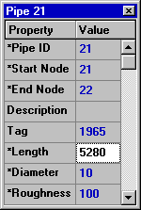

* The Editor is a grid with two columns - one for the property’s name and the other for its value.
* An asterisk next to a property name means that it is a required property – its value cannot be left blank.
* Depending on the property, the value field can be one of the following:
* A text box where you type in a value
* A dropdown list box where you select from a list of choices
* An ellipsis button which you click to bring up a specialized editor
* A read-only label used to display computed results
* The property in the Editor that currently has focus will be highlighted with a white background.
* You can use both the mouse and the Up and Down arrow keys on the keyboard to move between properties.
* To begin editing the property with the focus, either begin typing a value or hit the Enter key.
* To have EPANET accept what you have entered, press the Enter key or move to another property; to cancel, press the Esc key.
* Clicking the Close button in the upper right corner of its title bar will hide the Editor.

## **Program Preferences:**

## Program preferences allow you to customize certain program features. To set program preferences select **Preferences** from the **File** menu. A Preferences dialog form will appear containing two tabbed pages – one for General Preferences and one for Format Preferences.

**General Preferences:**

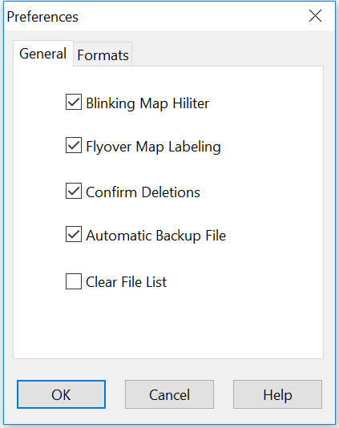

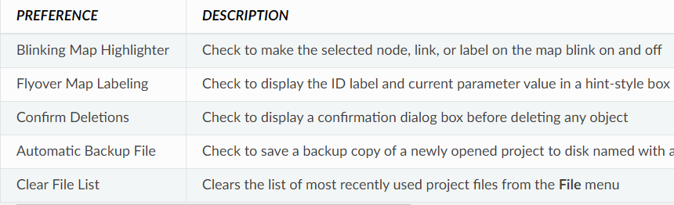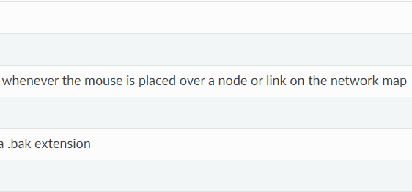

**Formatting Preferences:**

The Formats tab of the Preferences dialog box controls how many decimal places are displayed when results for computed parameters are reported.

